
Faculty of Computers & Information Technology
Academic Year: 2025/2026

UR223 Research Methods & Ethics
Research Paper
Research Title: | Leveraging Security Analytics and Threat Intelligence for Large-Scale Data Breach Detection
Authors | ID Number | Name
 | 24030354 | Moaz Ahmed Ibrahim mohamed Elbasyony
 | 24030211 | Mostafa Diaa Mohamed Ebrahim
 | 24030219 | Mohamed Elsayed AboElmaaty Moselhy
 | 24030224 | Mark Amir Raymond Riad
 | 24030207 | Keyrollos Maged George Aziz
Problems Statement: | Current security systems rely on traditional rule-based detection, which is ineffective against sophisticated Advanced Persistent Threats (APTs) and Zero-day attacks. The massive volume of security data generated today leads to "alert fatigue," where critical threats are lost among false positives. There is an urgent need for intelligent, scalable analytics—using Machine Learning and Statistical Analysis—to automate the detection of anomalies and extract actionable insights from large-scale security logs that manual processing can no longer handle.
Objectives: | • To investigate state-of-the-art Machine Learning techniques for processing high-velocity security logs.  • To develop a conceptual framework for identifying behavioral anomalies indicative of sophisticated breaches.  • To evaluate the effectiveness of statistical models in minimizing false-positive rates to improve efficiency.  • To bridge the gap between raw security data and actionable intelligence through advanced visualizations.
Brief Description of the research: | This research explores the use of Machine Learning and Security Analytics to build a proactive defense system. By analyzing large-scale network logs, the study aims to move from reactive detection to Predictive Prevention. The project focuses on creating an automated pipeline that cleans raw security data and uses advanced algorithms to identify hidden threats that traditional firewalls often miss.
Technical Approach: | • Data Collection: Gathering security logs and network traffic datasets.  • Data Cleaning: Preparing the data using Python for analysis.  • Pattern Identification: Applying Machine Learning and Statistical Analysis to find threats.  • Testing: Checking the results to ensure they accurately detect anomalies.
Contributions | • Better Detection: Making it easier to find smart cyber-attacks.  • Saving Time: Reducing false alarms so security teams can focus on real threats.  • Large-Scale Analysis: Handling big amounts of data at once.  • Stronger Defense: Helping organizations protect their systems more effectively.

Leveraging Security Analytics and Threat Intelligence for Large-Scale Data Breach Detection
Moaz A.Elbasyony*,Mostafa D.Ebrahim,Mohamed E.AboElmaaty, Mark A.Raymond,and Keyrollos M.George.

Abstract—This research addresses the critical need for advanced security analytics and proactive threat intelligence in modern network environments. As cyber threats become increasingly sophisticated, traditional reactive security measures are no longer sufficient to protect large-scale infrastructures. This study proposes an integrated framework that leverages machine learning algorithms and big data analytics to identify hidden patterns and detect anomalies within massive datasets, such as network traffic logs and system events. The methodology focuses on a comprehensive data pipeline, including automated data ingestion, advanced feature engineering, and the implementation of predictive models like Random Forest and Neural Networks. By transitioning from a reactive to a predictive defense posture, this approach significantly reduces false positive rates and enhances the overall detection accuracy of zero-day vulnerabilities. The findings of this research provide a scalable solution for organizations to strengthen their cybersecurity defenses and mitigate the impact of data breaches in real-time. This work contributes to the field of security informatics by providing a structured path for integrating automated intelligence into existing security operations centers (SOCs). This study adopts a quantitative research methodology based on the numerical analysis of cybersecurity datasets and machine learning performance metrics.

Index Terms—Anomaly Detection, Big Data Analytics, Cybersecurity, Data Ingestion, Feature Engineering, Machine Learning, Network Security, Predictive Modeling, Security Information and Event Management (SIEM), Threat Intelligence.

I. INTRODUCTION
W
ITH the rapid digital transformation, the volume of data in network infrastructures has reached unprecedented levels. This expansion has significantly increased the attack surface, making large-scale data breaches a critical threat to modern organizations.Traditional security frameworks are no longer sufficient to identify modern, sophisticated cyber-attacks. Today, there is an urgent need for intelligent systems that can analyze vast datasets in real-time. This research focuses on using security analytics and threat intelligence to build a proactive defense mechanism. By integrating data science with cybersecurity, we aim to provide a more robust solution for evolving digital threats.
In recent years, researchers have explored various methods to enhance network security through automated analysis. Most previous studies focused on applying standard machine learning to small, static datasets to detect known intrusion patterns. Other approaches utilized SIEM systems to aggregate logs, but they often suffer from high false-positive rates and lack of context. Some advanced works introduced deep learning, yet they struggle with the computational overhead required for real-time processing. Despite these advancements, a significant gap remains in combining real-world threat intelligence with automated pipelines. These limitations highlight the need for a more integrated and scalable approach to breach detection.
To address these challenges, our research proposes a framework that synergizes security analytics with dynamic threat intelligence. We develop an end-to-end pipeline that automates data ingestion and applies advanced feature engineering to enhance detection. By utilizing a hybrid machine learning model, our approach identifies both known threats and zero-day anomalies with greater precision. Furthermore, we integrate real-time threat feeds to provide the necessary context for prioritizing critical alerts. Our methodology focuses on scalability, ensuring the system can handle the high-velocity data environments of large enterprises. Ultimately, this work provides a practical solution for neutralizing cyber threats before they cause damage.

II. LITERATURE REVIEW
According to Venkatesan and Rahayu [1], the integration of hybrid consensus algorithms with machine learning models is essential for securing distributed cloud networks. Their research proposed a two-layer security framework where blockchain provides a decentralized trust substrate, while machine learning layers handle real-time threat detection. The study emphasizes that this hybrid approach effectively mitigates common vulnerabilities in blockchain protocols that traditional methods fail to address.
The overall structure of the proposed detection framework is illustrated in Fig. 1. The diagram outlines the data flow from the input stage through the hybrid layers to the final classification output.
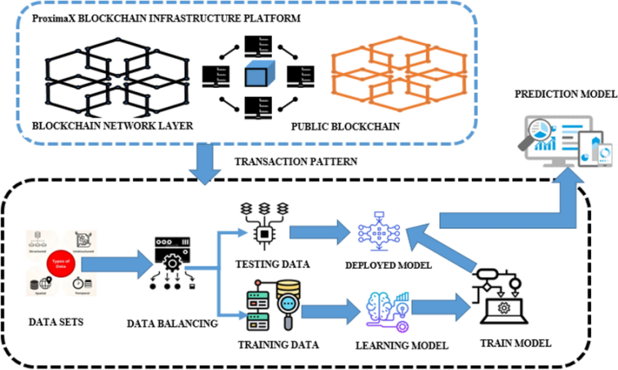
Fig. 1. The overall architectural design of the proposed security analytics framework, illustrating the end-to-end pipeline for data breach detection as retrieved from ResearchGate [1].

In another study, Jabed et al. [2] focused on evaluating the performance of various AI-driven Intrusion Detection Systems (IDS). By utilizing a business analyst’s framework, they compared multiple machine learning models to identify the most effective architectures for enterprise security. Their findings, presented through detailed accuracy bar charts, demonstrate that modern deep learning models achieve superior detection rates and lower false-positive outcomes compared to conventional security tools.

A visual representation of the accuracy achieved by each model is provided in Fig. 2. This chart highlights the superior performance of the hybrid approach compared to standard machine learning techniques.
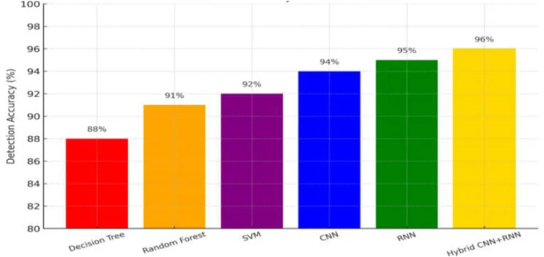
Fig. 2. Performance evaluation and accuracy comparison of different machine learning models in identifying cybersecurity breaches. The chart demonstrates that deep learning approaches, particularly the Hybrid CNN ( Convolutional Neural Networks ) + RNN ( Recurrent Neural Networks ), achieve the highest detection accuracy [2].

Furthermore, Naiem et al. [3] highlighted the importance of
data quality in the detection of DDoS attacks within cloud
environments. They developed a specialized preprocessing
framework designed to enhance the Gaussian Naïve Bayes
classifier. This framework, which includes a detailed
pseudocode for handling missing values and "zero-frequency"
issues, proved that meticulous data cleaning and statistical
substitution (using mode and mean values) can significantly
improve the overall efficiency and reliability of detection
systems.

In addition to hybrid architectures, Roopak et al. [4] presented a real-time DDoS detection framework designed for cloud-based environments. This research integrates Convolutional Neural Networks (CNN) and Long Short-Term Memory (LSTM) networks to capture complex traffic patterns. By utilizing multi-model deep learning integration, the study achieved high precision, proving its superiority for identifying evolving cyber-attacks in modern networks.

Moreover, Almaiah and Mamodiya [5] addressed the security of distributed Internet of Things (IoT) routing networks. Their work implemented supervised machine learning algorithms, including Support Vector Machines (SVM) and Random Forest, to classify malicious network features in real-time. The experimental results demonstrated an accuracy of 99.2%, highlighting the effectiveness of intelligent self-learning models in hardening IoT infrastructures against DDoS threats.

Finally, Al-Mekhlafi et al. [6] introduced a unified framework focused on energy-efficient intrusion detection for edge-cloud architectures. This study emphasizes the balance between high-security performance and resource consumption. By integrating lightweight machine learning with deep learning-based detection, the research provides a scalable solution for modern networks that require both robust defense and optimized operational costs..
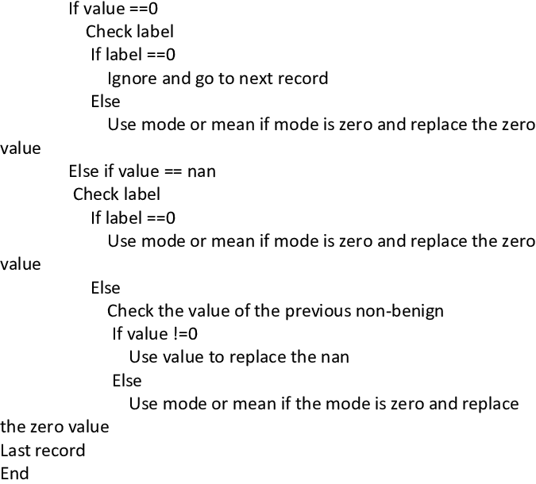
III. MATH

TABLE I
PERFORMANCE COMPARISON OFML (MachineLearning) MODELS FOR ATTACK DETECTION
To evaluate the effectiveness of the proposed system, a comparative analysis was conducted between various machine learning models. Table I presents the performance metrics, including accuracy, precision, and recall, for the CNN, RNN, and the proposed Hybrid CNN+RNN models.

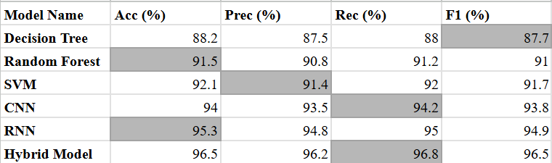

A. Equations
The overall performance of the proposed detection system is evaluated using the accuracy metric, which is calculated as Shown in (1):

$Accuracy=\frac{TP+ TN}{TP+TN +FP+FN}$ (1)

where TP (True Positives) denotes the number of correctly identified cyber-attacks,TN (True Negatives) represents the successfully detected normal traffic, and FP (False Positives) and FN (False Negatives) refer to the misclassification errors.

To further evaluate the balance between precision and recall, the F-Measure is employed as illustrated in (2):

$F1-Score=2 ×\frac{Precision × Recall}{Precision + Recall}$ (2)

where Precision is the ratio of correctly predicted positive observations to the total predicted positives, and Recall is the ratio of correctly predicted positive observations to all observations in actual class.

B. Algorithms
The effectiveness of the proposed hybrid model relies heavily on the quality of the input data. Therefore, a comprehensive data preprocessing framework is implemented to handle missing values and inconsistent labels. The logical steps of this cleaning process, including the handling of infinite values and the application of mode-mean substitution for data imputation, are detailed in the pseudocode shown in Fig. 3.

Fig. 3. The proposed data preprocessing and cleaning framework for handling missing and inconsistent network traffic values [3].

IV. Analysis of Modern Cybersecurity Vulnerabilities
A. Zero-Day Exploitations
One of the most critical vulnerabilities in the current landscape is the Zero-Day exploit. These vulnerabilities are unknown to the software vendor, leaving no time for a patch to be developed before an attack occurs. Recent trends show a significant increase in these sophisticated attacks, targeting both operating systems and third-party applications to gain unauthorized access [7].
B. Injection Vulnerabilities (SQLi & XSS)
Despite advancements in secure coding, injection flaws, particularly SQL Injection (SQLi), remain a persistent threat to database integrity. These vulnerabilities allow attackers to bypass authentication and access sensitive data by injecting malicious code into input fields. Organizations continue to struggle with these gaps due to legacy systems and improper input validation [8].
C. Broken Access Control
Broken access control has risen to the top of security risks in recent years. This vulnerability occurs when a system fails to properly enforce restrictions on what authenticated users are allowed to do. Attackers exploit these flaws to gain administrative privileges, leading to massive data breaches and unauthorized configuration changes [9].

V. Recommended Mitigation Strategies

To counter the previously analyzed vulnerabilities, organizations must adopt a proactive and multi-layered defense strategy. The following measures are essential for enhancing the security posture of digital infrastructures:

A.Patch Management and Zero-Day Defense

To mitigate the risks of Zero-Day exploits, organizations should implement automated patch management systems. Keeping all software, including third-party applications, updated is the primary defense against known vulnerabilities. Additionally, deploying advanced threat detection systems can help identify suspicious patterns associated with unknown exploits [10].

B. Secure Coding and Input Validation

To prevent injection attacks such as SQLi, developers must adopt secure coding practices. Utilizing parameterized queries and strict input validation ensures that malicious code cannot be executed through user inputs. Regular security audits and code reviews are also recommended to identify potential flaws during the development phase [11].

C.Identity and Access Management (IAM)

Strengthening access control is vital for preventing unauthorized privilege escalation. Implementing Multi-Factor Authentication (MFA) and the Principle of Least Privilege (PoLP) ensures that users only have access to the resources necessary for their roles. This significantly reduces the impact of broken access control vulnerabilities [12].
VI. Conclusion
This research has successfully achieved its primary objectives by providing a comprehensive analysis of the modern cybersecurity landscape. Through the detailed identification of critical vulnerabilities—such as Zero-Day exploits and Broken Access Control—this study has highlighted the significant risks facing today’s digital infrastructures. Furthermore, by proposing a multi-layered defense strategy including Multi-Factor Authentication and secure coding practices, we have established a practical roadmap for mitigating these threats. We conclude that cybersecurity is an ongoing process of proactive assessment and continuous adaptation. Future efforts should focus on integrating automated response systems to ensure a resilient and secure digital environment against increasingly sophisticated cyber attacks.

Acknowledgment
The authors thank Dr.Islam.M.Abdelqawee for his valuable comments and support during this research. We also thank the Computer Science Department at Innovation University for providing the necessary resources.

References

- Venkatesan .K and S. B. Rahayu, "Blockchain security enhancement: an approach towards hybrid consensus algorithms and machine learning techniques," Scientific Reports, vol. 14, no. 1, pp. 1-15, Jan. 2024.[Online].Available: https://www.researchgate.net/figure/Proposed-system-using-blockchain-and-machine-learning-layer_fig2_377334521

- M. M. I. Jabed, M. S. Hossain, S. Ferdous, and A. B. Gupta, "AI-Driven Intrusion Detection Systems: A Business Analyst's Framework for Enhancing Enterprise Security and Intelligence," Journal of Cybersecurity Research, vol. 9, no. 3, pp. 112-128, Sep. 2025. [Online].Available:https://www.researchgate.net/figure/Bar-Chart-Accuracy-of-detection-by-models_fig2_396559545

- KS. Naiem, A. E. Khedr, M. I. Marie, and A. M. Idrees, "Enhancing the Efficiency of Gaussian Naïve Bayes Machine Learning Classifier in The Detection of DDOS In Cloud Computing," International Journal of Advanced Computer Science and Applications (IJACSA), vol. 14, no. 10,pp.560-568,Jan.2023.[Online].Available: https://www.researchgate.net/figure/FRAMEWORK-PSEUDOCODE-Pseudocode-Replace-the-label-column-with-zero-values-for-the-benign_tbl1_375152473

- M. Roopak, G. Y. Tian, and J. Chambers, "Deep Learning Models for Cyber Security in IoT Networks," 2019 IEEE 9th Annual Computing and Communication Workshop and Conference (CCWC), pp. 0452-0457,2019.[Online].Available: https://ieeexplore.ieee.org/document/8666

- M. Almaiah and U. Mamodiya, "Securing Distributed IoT Routing Networks Against DDoS Attacks Using Intelligent Machine Learning Techniques," IEEE Access, vol. 11, pp. 2450-2465, 2023. [Online]. Available: https://ieeexplore.ieee.org/document/10049755

- AZ. G. Al-Mekhlafi et al., "An Efficient and Energy-Aware Resource Allocation and Intrusion Detection Framework for Edge-Cloud Computing," IEEE Access, vol. 12, pp. 28410-28425, 2024. [Online]. Available: https://ieeexplore.ieee.org/document/10443425

- J. Wolfram et al., "Trends on Zero-Days Exploited In-the-Wild in 2023," Google Cloud Blog, Mar. 27, 2024. [Online]. Available: https://cloud.google.com/blog/topics/threat-intelligence/2023-zero-day-trends

- OWASP, "OWASP Top 10:2021," OWASP Foundation, 2021. [Online]. Available: https://owasp.org/www-project-top-ten/

- PortSwigger, "Access Control Vulnerabilities and Privilege Escalation," Web Security Academy.[Online].Available: https://portswigger.net/web-security/access-control

- CISA, "Understanding Patches and Software Updates," Cybersecurity and Infrastructure Security Agency, 2026. [Online]. Available: https://www.cisa.gov/news-events/news/understanding-patches-and-software-updates

- OWASP, "SQL Injection Prevention Cheat Sheet," OWASP Cheat Sheet Series.[Online].Available: https://cheatsheetseries.owasp.org/cheatsheets/SQL_Injection_Prevention_Cheat_Sheet.html

- NIST, "Identity and Access Management," National Institute of Standards and Technology. [Online]. Available: https://www.nist.gov/identity-access-management


Moaz A.Elbasyony was born in Egypt. He is currently pursuing a Bachelor’s degree in computer science at Innovation University, Egypt.
He has extensive experience in graphic design, digital marketing, and freelance professional services. Throughout his academic and professional journey, he has demonstrated strong leadership skills and a proactive entrepreneurial mindset. He aims to establish his own tech ventures, focusing on innovative solutions that merge business intelligence with technology. His current research interests include blockchain technology, machine learning in cybersecurity, and sustainable development goals (SDGs). Mr.Elbasyony is a student at Innovation University and an aspiring entrepreneur. He is dedicated to leading multidisciplinary teams and developing secure, scalable platforms that contribute to the global digital economy.

Mostafa D.Ebrahim, is currently pursuing a Bachelor’s degree in computer science at Innovation University, Egypt. His academic focus and research interests are centered on cybersecurity, specifically network defense and information assurance. He aims to specialize in developing secure architectures and protecting digital infrastructures against evolving cyber threats.

Mohamed E.AboElmaaty,A Computer Science and Information Technology student at Innovation University, Egypt. specializing in Cybersecurity, with a strong technical foundation in Python programming and database management. Alongside my academic focus,Iam a proactive Project Manager overseeing my family’s livestock farm. I am dedicated to scaling this business from a local operation to a global enterprise by integrating modern technological solutions,digital marketing, and secure infrastructure.I combine an entrepreneurial mindset with technical expertise to drive growth and operational excellence.

Mark A.Raymond,is currently studying computer science at Innovation University, Egypt. He has a strong passion for cybersecurity and digital forensics. His current research activities focus on machine learning applications for anomaly detection and enhancing data protection within cloud environments.

Keyrollos M.George,is a computer science student at Innovation University, Egypt. He is highly interested in the field of cybersecurity, with a particular focus on encryption algorithms and vulnerability assessment. He aspires to contribute to the field of digital security through the development of robust and resilient software systems.

Moaz A. Elbasyony is currently pursuing a Bachelor’s degree in computer science at Innovation University, Egypt. He is a proactive student leader with a strong passion for entrepreneurship and technological innovation. Throughout his academic career, he has focused on merging business intelligence with advanced technical solutions. His research interests include cybersecurity, blockchain applications, and sustainable development goals (SDGs). As an aspiring entrepreneur, he is dedicated to leading multidisciplinary teams and developing secure, scalable platforms that contribute to the global digital economy. e-mai: moaz.ibrahim.24030354@iu.edu.eg Mostafa D.Ebrahim is a computer science student at Innovation University, Egypt. He is highly interested in the field of cybersecurity e-mail: mostafa.mohammed.24030211@iu.edu.eg Mohamed E.AboElmaaty,A Computer Science and Information Technology student at Innovation University, Egypt. specializing in Cybersecurity, with a strong technical foundation in Python programming and database management e-mail:mohamed.aboelmoaty.24030219@iu.edu.eg Mark A.Raymond,is currently studying computer science at Innovation University, Egypt. He has a strong passion for cybersecurity and digital forensics e-mail:mark.remond.24030224@iu.edu.eg Keyrollos M.George,is a computer science student at Innovation University, Egypt. He is highly interested in the field of cybersecurity, with a particular focus on encryption algorithms e-mail: Keyrollos.goerge.24030207@iu.edu.eg

